10/7/2026
Instructor: Sir M. Fahad Qasim
Submitted by: Wasif Ali
Reg id: 245187
Class: BSCS F24 B


HTML
Full-Stack Development Lab
Lab No 05

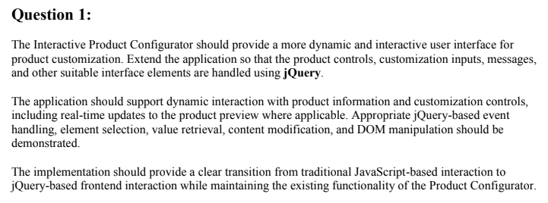

jQuery Implementation:

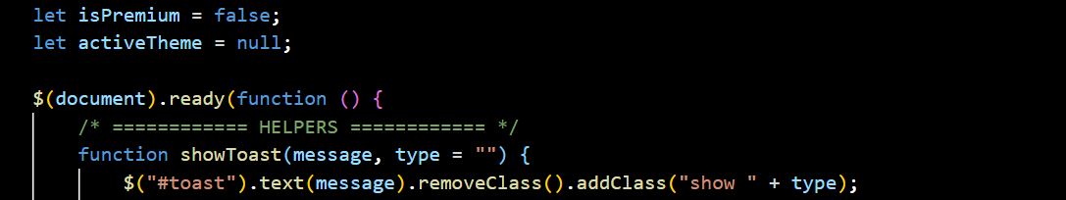

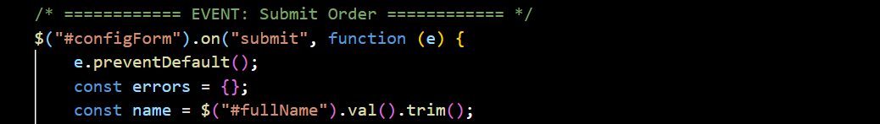

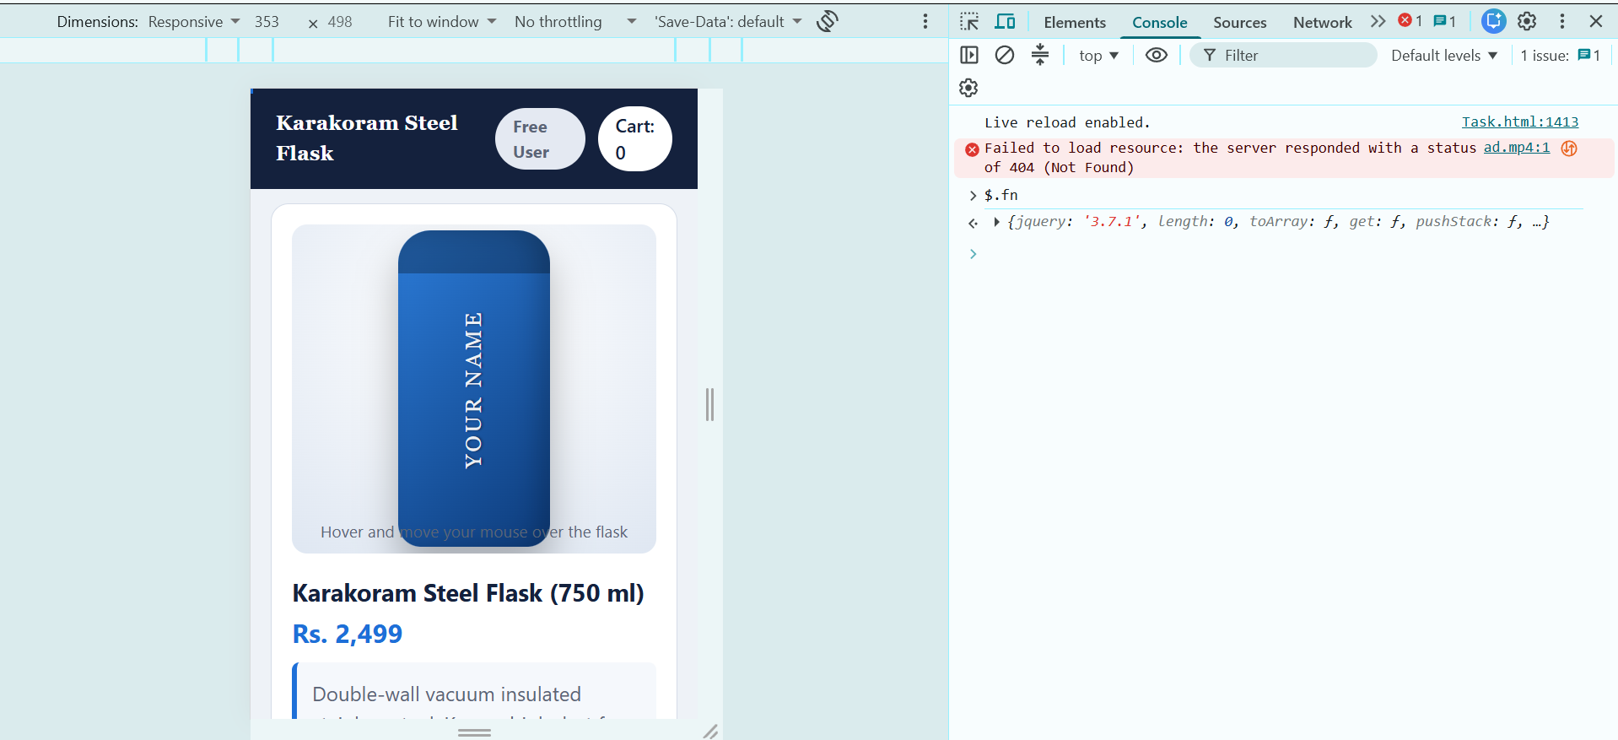

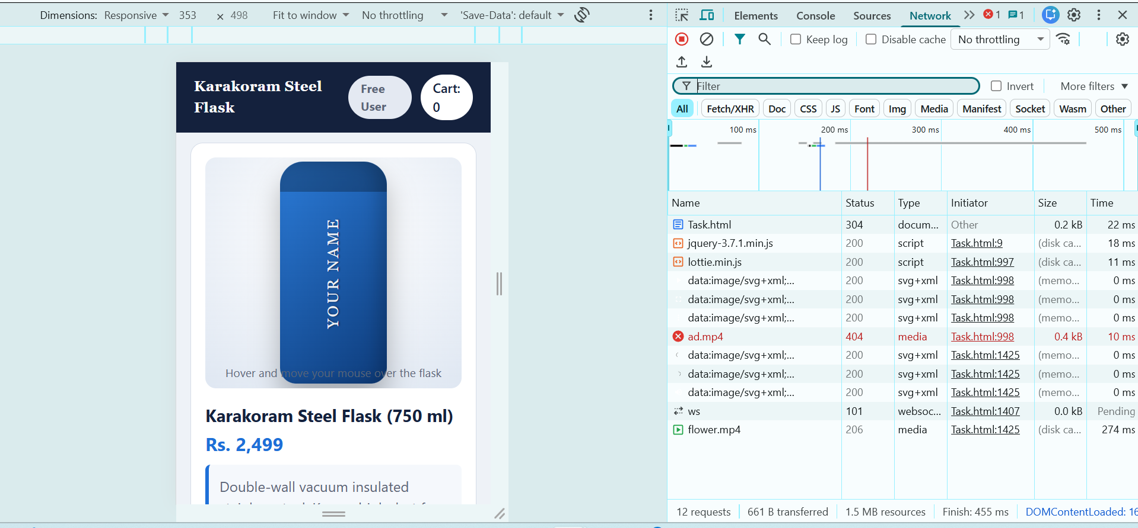

Result:

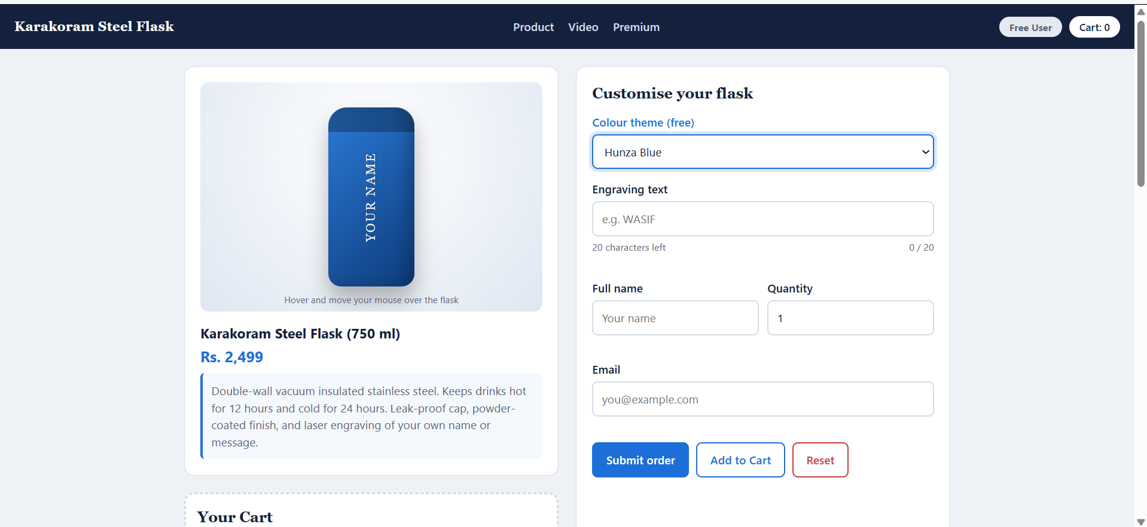

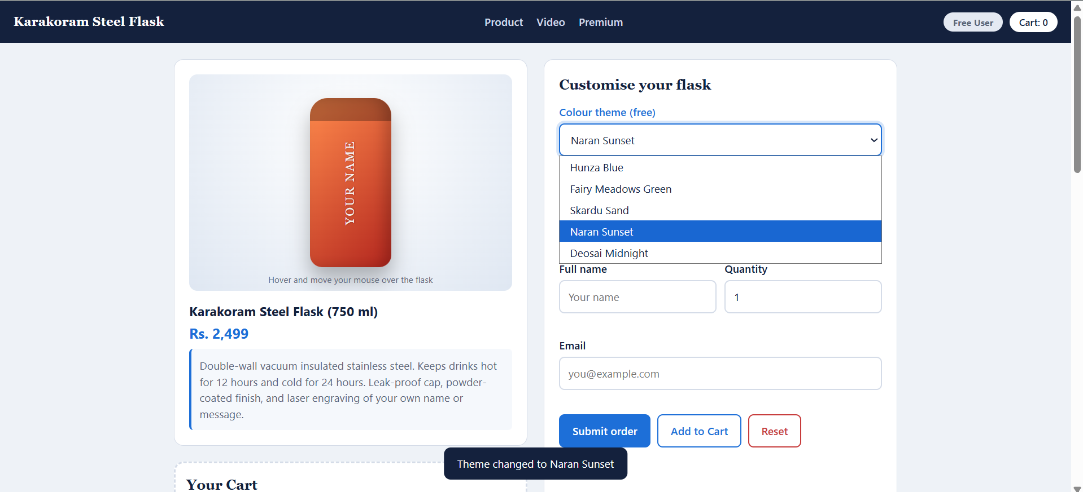

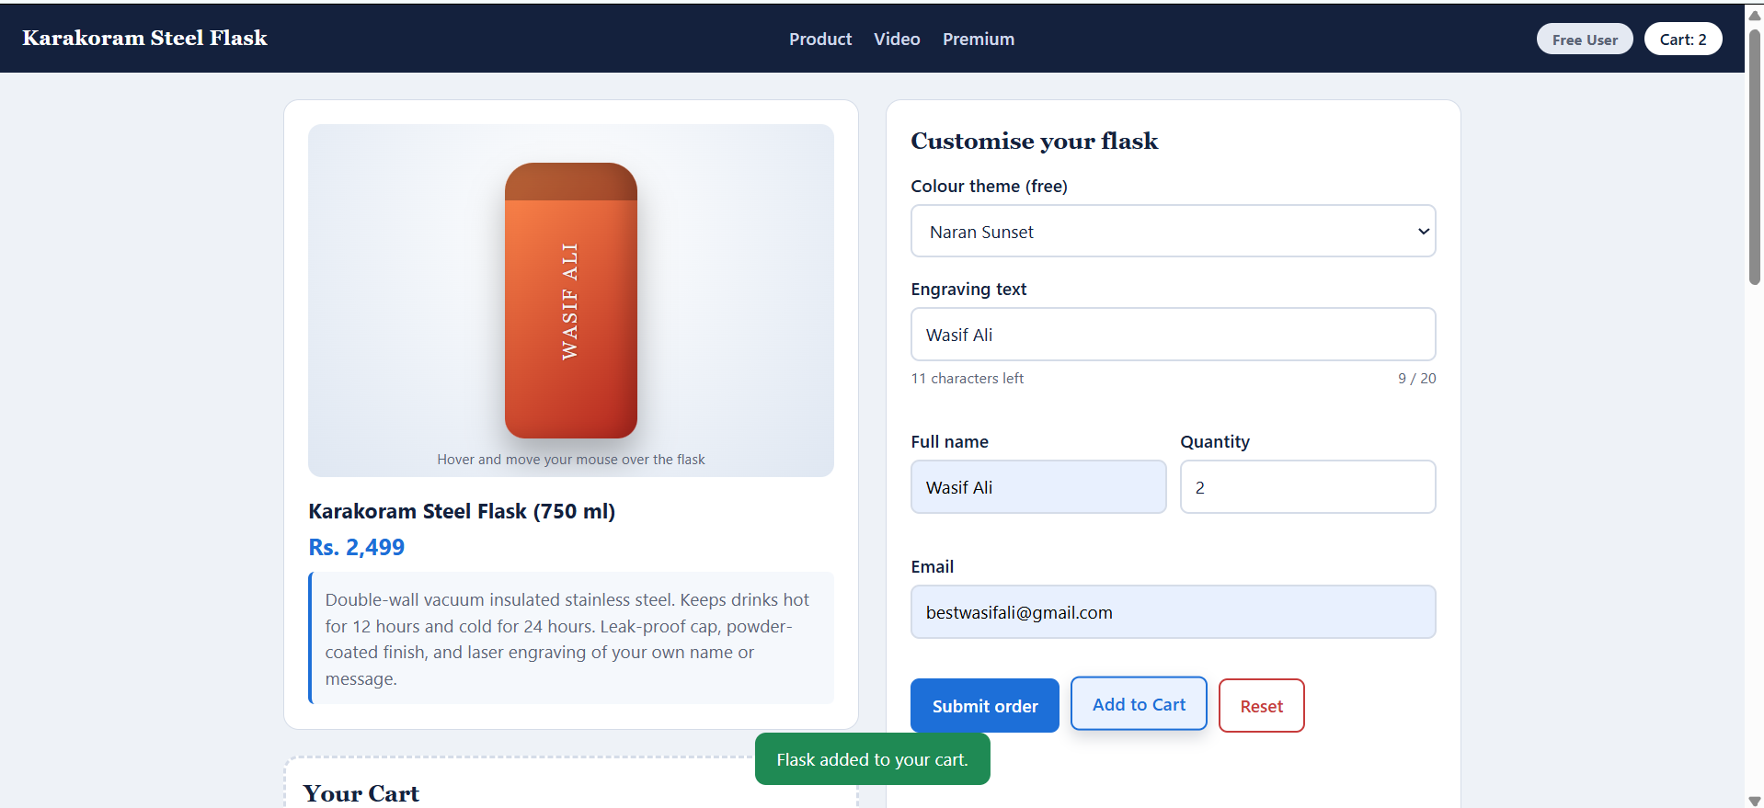

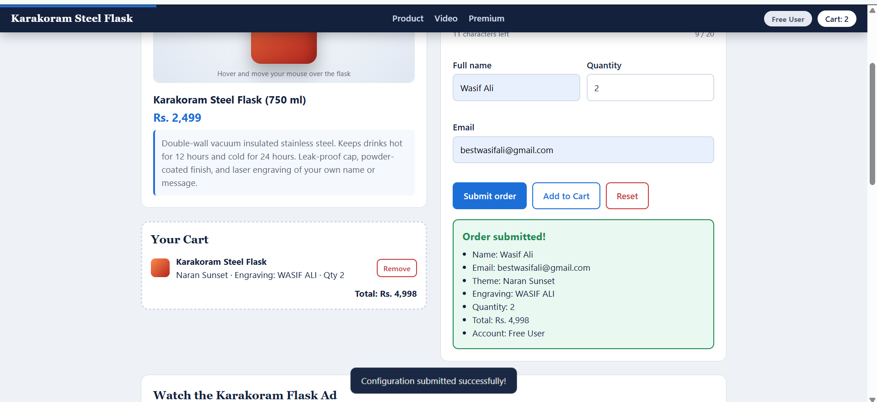
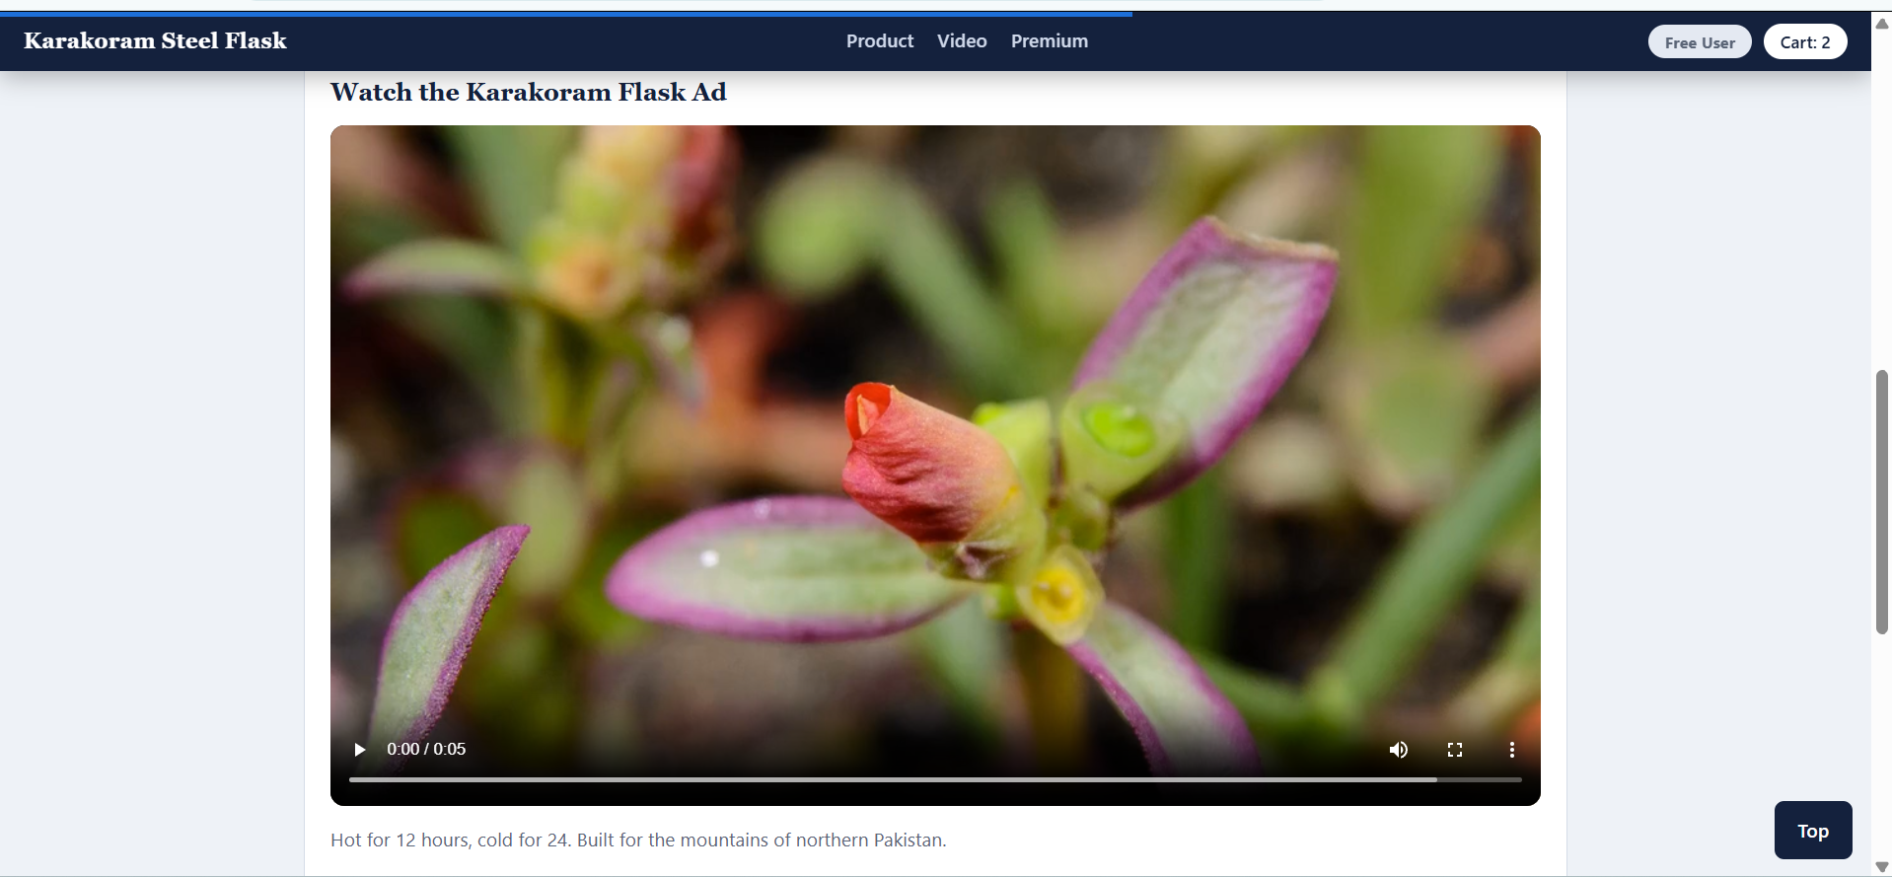
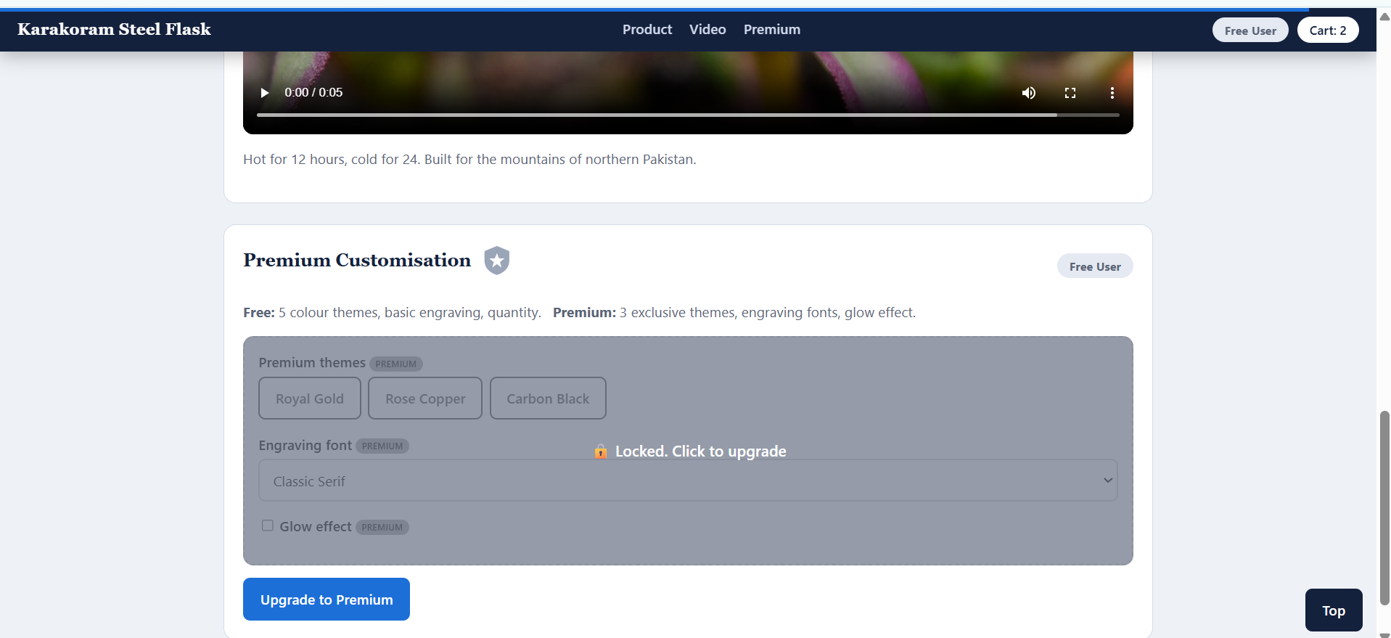
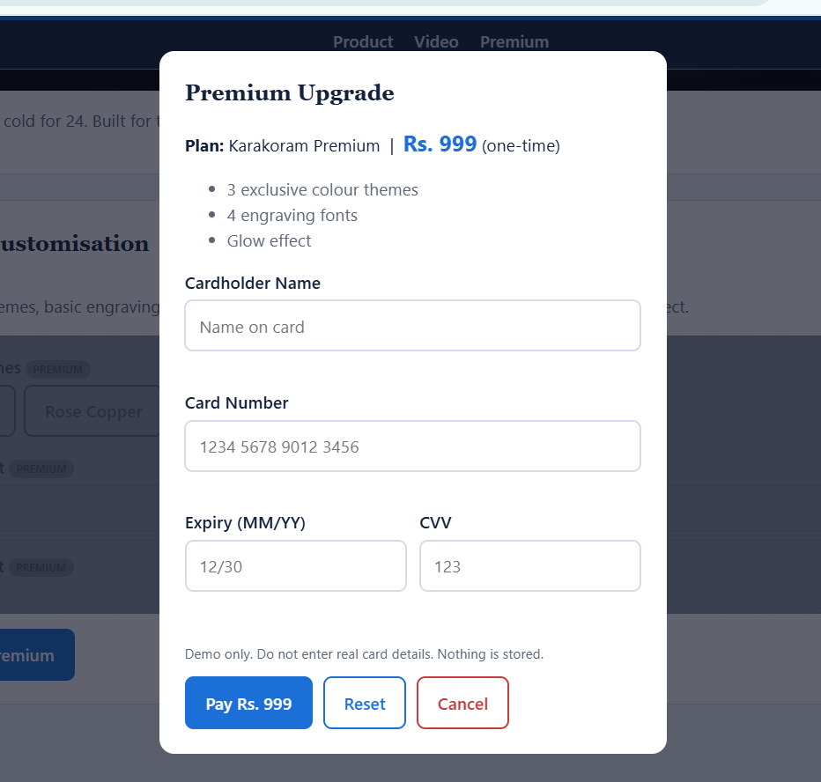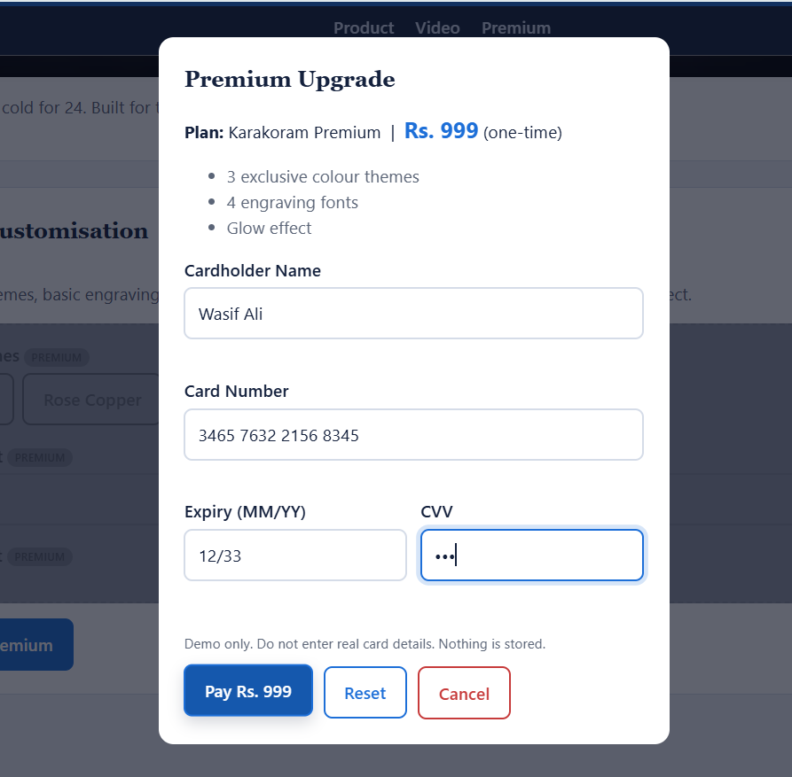
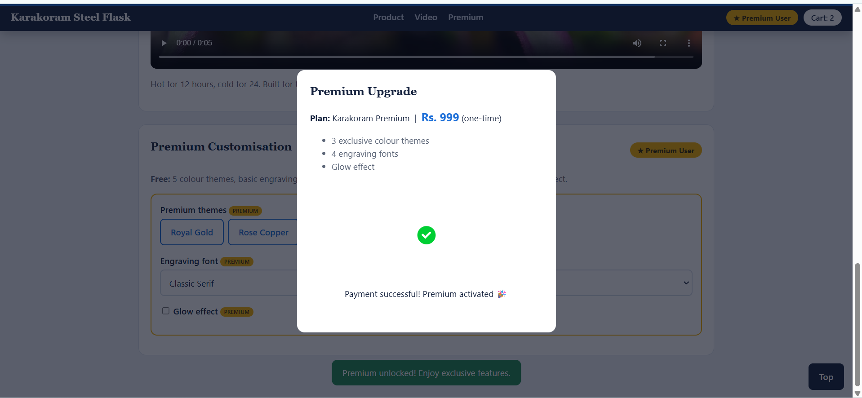
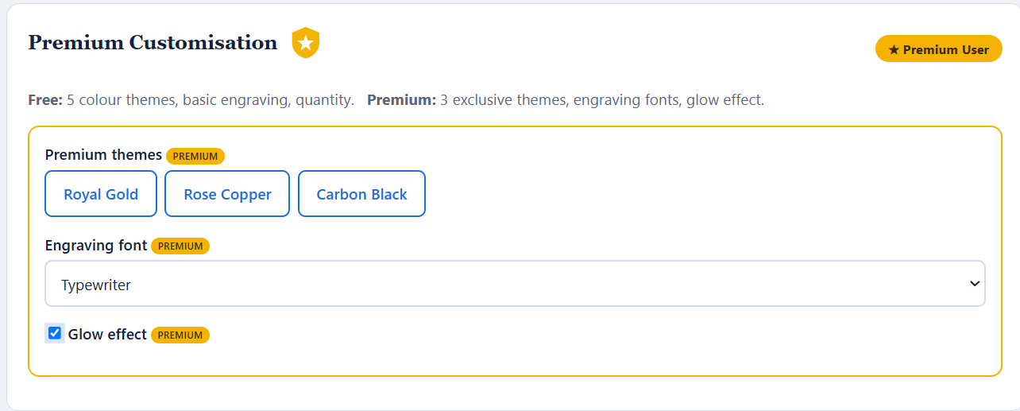

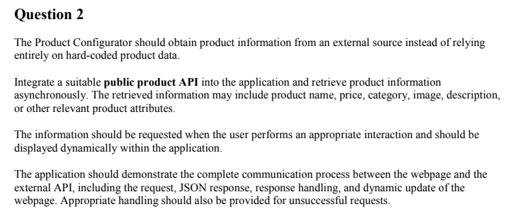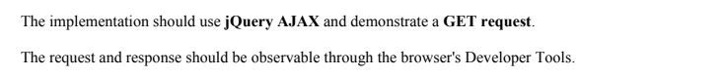
jQuery AJAK Implementation:
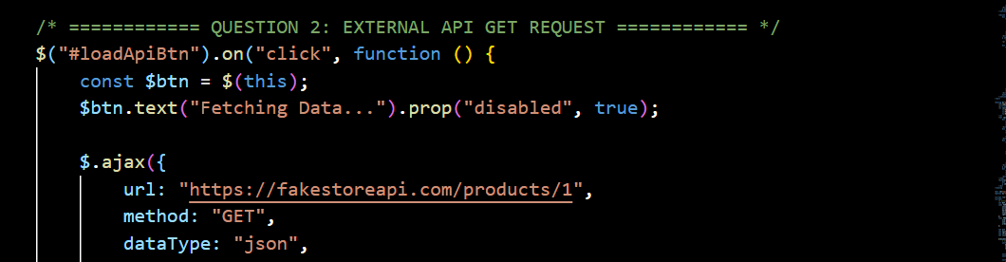
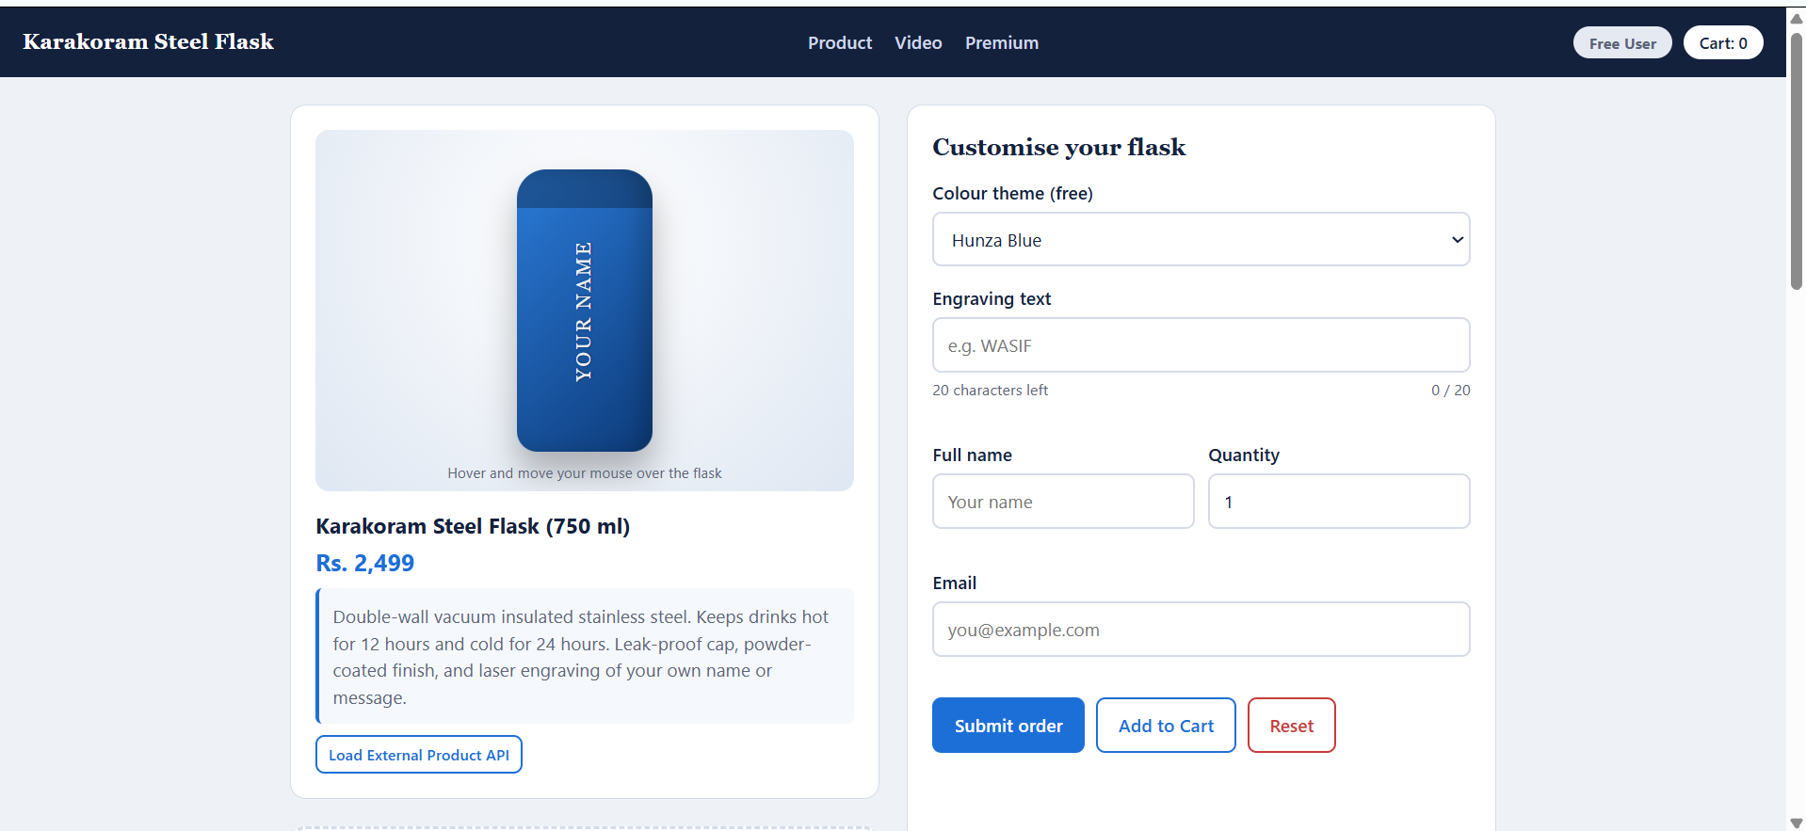
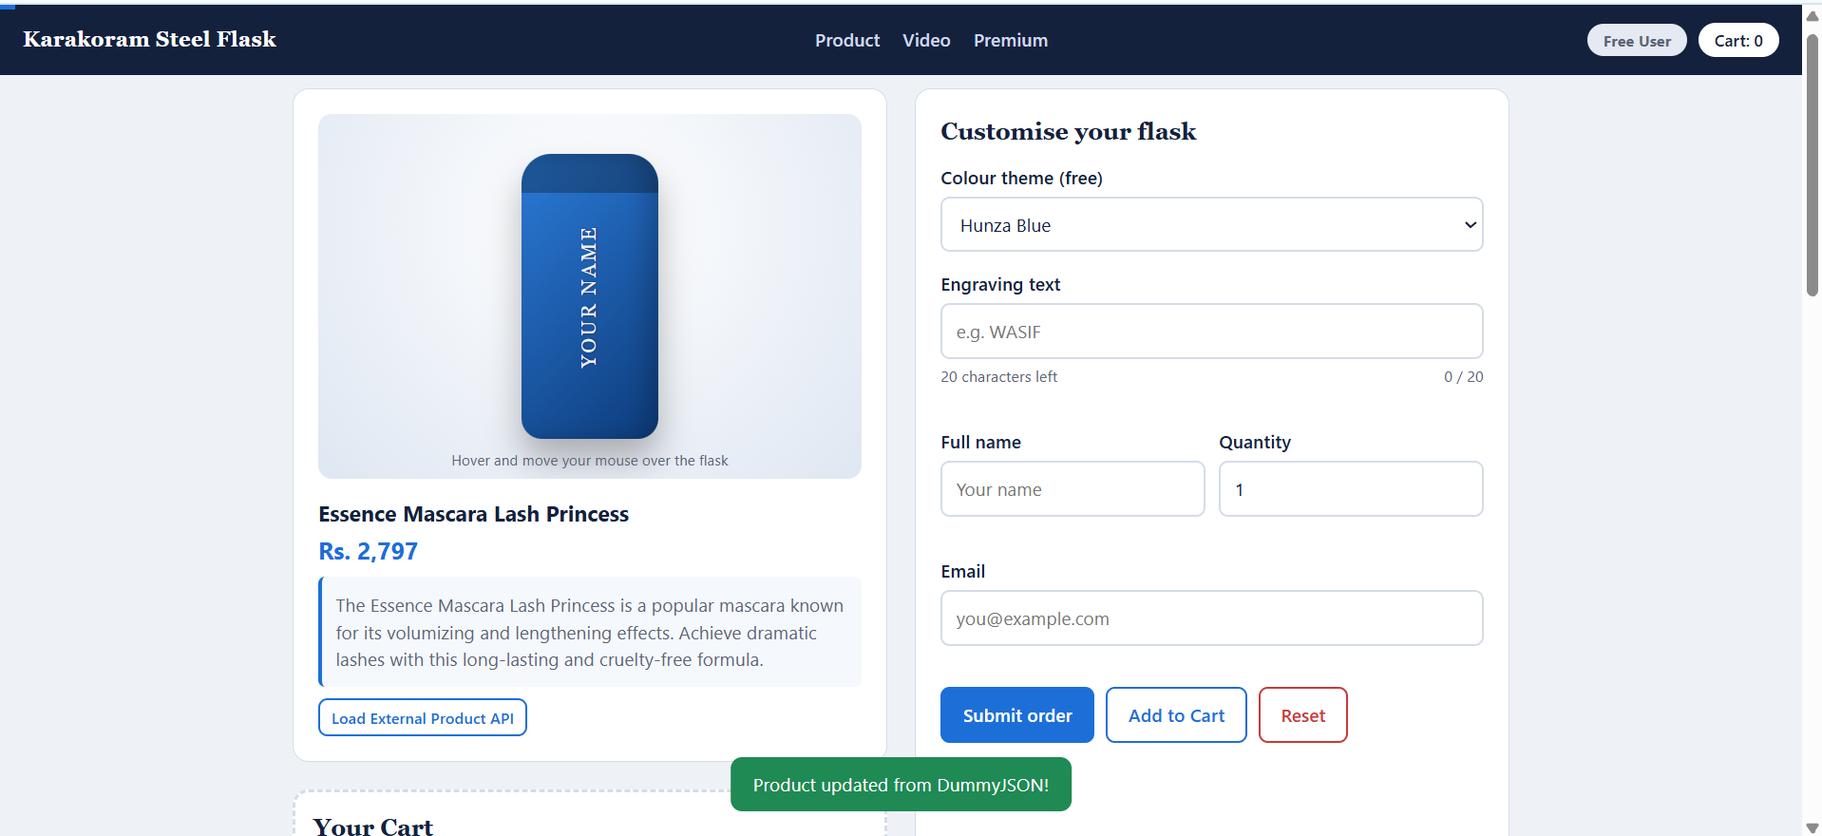

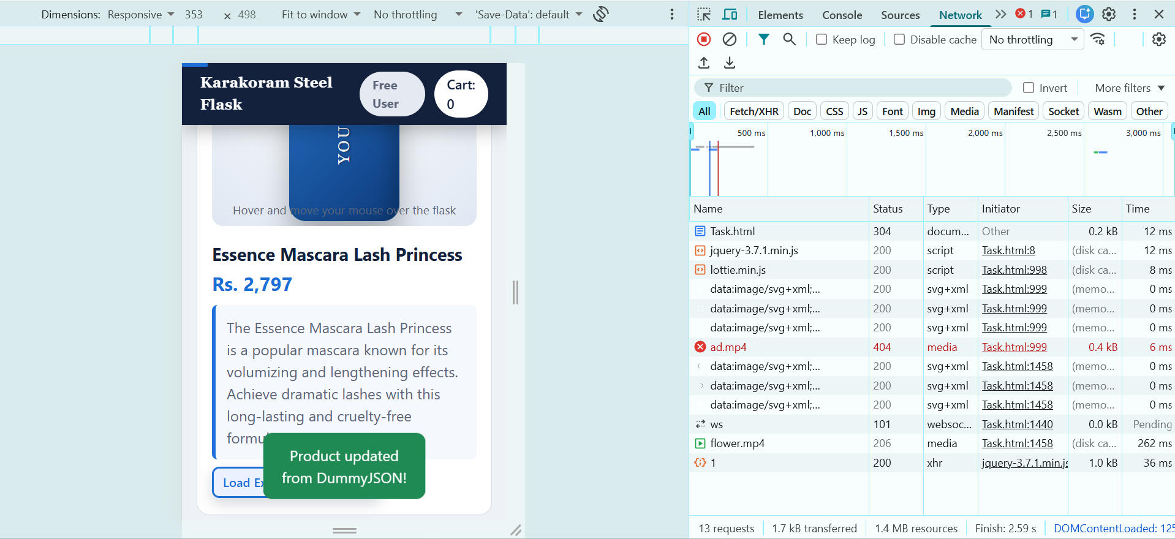

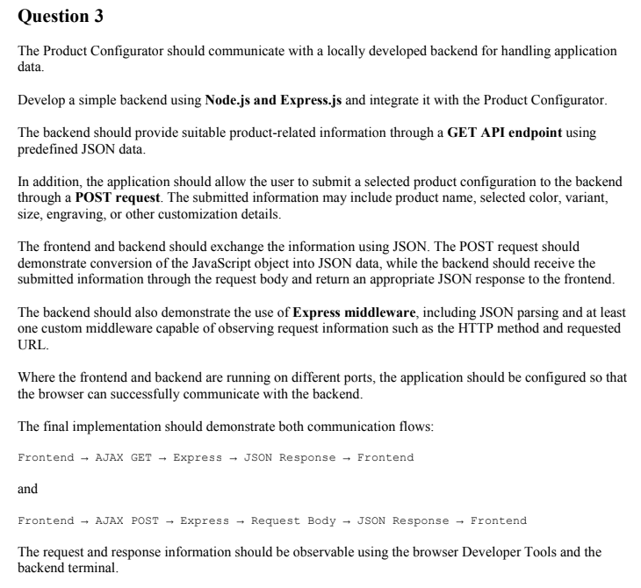
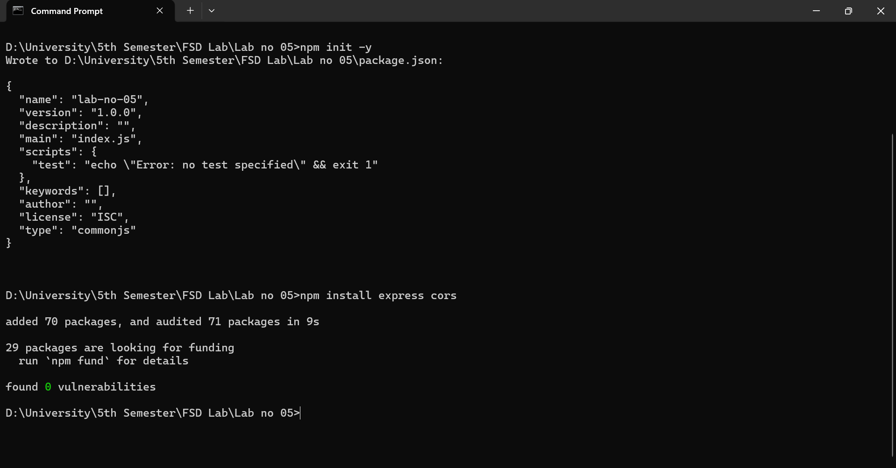

Server.js code:
const express = require('express');
const cors = require('cors');

const app = express();
const PORT = 3000;

// 1. CORS Middleware (allows your HTML file to talk to this server)
app.use(cors());

// 2. Built-in Middleware for JSON parsing
app.use(express.json());

// 3. Custom Middleware (logs HTTP method and requested URL)
app.use((req, res, next) => {
console.log(`[LOG] ${req.method} request made to: ${req.url}`);
next();
});

// GET API Endpoint (Predefined JSON data)
app.get('/api/product', (req, res) => {
res.json({
id: 101,
title: "Karakoram Special Edition",
description: "Fetched from local Express backend. Premium insulated flask.",
price: 2999
});
});

// POST API Endpoint (Receives the frontend configuration)
app.post('/api/order', (req, res) => {
const orderData = req.body;

// Log the received JSON data in the backend terminal"
console.log("=== New Order Received ===");
console.log(orderData);

// Send a JSON response back to the frontend
res.json({
status: "success",
message: "Order successfully processed by Node.js Backend!",
received_data: orderData
});
});

app.listen(PORT, () => {
console.log(`Backend server running at http://localhost:${PORT}`);
});

